

CV

CVCV

**Billing Information**

Name: ___________________________________________________

Street Address: __________________________________________

City, State, Zip Code: ____________________________________

Phone: __________________________________________________

Email: ____________________________________________________

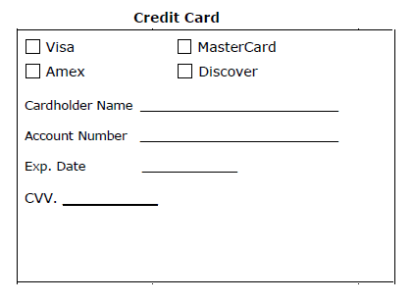

**Shipping Information**

Same as billing address

Commercial Residential

Name: ___________________________________________________

Street Address: __________________________________________

City, State, Zip Code: ____________________________________

Phone: __________________________________________________

Email: ____________________________________________________

Add Signature Required

(Additional $6 added to bill)

**Flowmeter Calibration Request Form**

Our current calibration turn-around time is typically 3-7 business days.

Please fill out all fields, and please use a separate form for each piece of equipment.

**Include this paperwork with your repair shipment.**

**Flowmeter Information**

Select your model:

Serial Number: ­­­­­­­_______________________________________

Concerns & Issues:

**Shipping Directions**

* **DO NOT ship additional flowmeter accessories.** Including nasal hoods, scavenging tubing, manuals, stands w/ wheels, mounts, hoses etc. We are not responsible for them, they were sent at your risk. If they are sent, additional shipping charges **will** incur.
* **Package with great care & this paperwork**

**Ship to:**

**Medical Testing Solutions**

**1001 NW 31 Ave**

**Pompano Beach, FL 30069**

**Payment**

**$300 for Calibration**

I understand that should additional/extensive repairs were required above the $300, you will be notified.

I understand it’s possible that the flowmeter might be irreparable – only a $75 diagnostic fee will be charged to my credit card

I understand my credit card will be charged after it’s serviced, but prior to its shipment

Please call me prior to charging the credit card

Signature: ­­­­­­­­______________________________________________